Geometry: Unit 12, Lesson 9

- The standard form of a circle is shown $x^{2}+ y^{2}+6x-12y-17=0$. Some of the steps Jenelda took to write the equation of the circle in center-radius form are shown.
Step | Jenelda’s Work
1.1. | $$x^{2}+ y^{2}+6x-12y-17=0$$
2.2. | $$x^{2}+6x+ y^{2}-12y=17$$
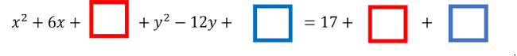
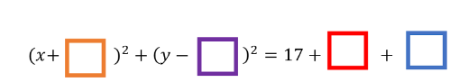
Some of Jenelda’s third step is shown.
Some of Jenelda’s fourth step is shown.
What value should Jenelda put in the red, blue, orange, and purple boxes?
$red=9, blue=36, orange=3, purple=6$

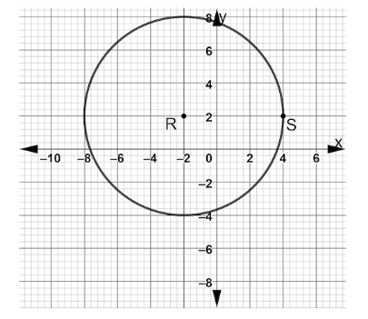
- Circle $R$ is shown on the coordinate plane. What are the coordinates of the center of Circle $R$? What is the radius of circle $R$?

$\left(-2,2\right),$_{radius = 6 units}

- In a circle whose equation is ${(x+7)}^{2}+ y^{2}=64$. What are the coordinates of its center? What is the circles radius?

$$\left(-7,0\right), radius=8 units$$

